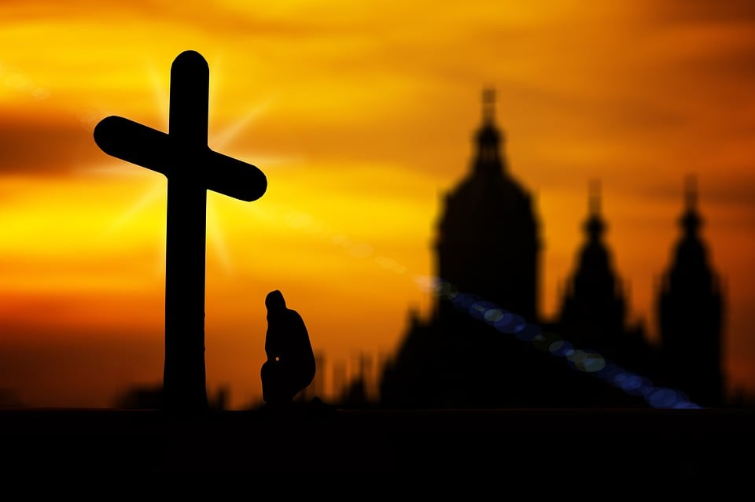
The Lord’s Prayer
Holy God, we come to you with people across the world and many centuries, calling you Our Father in heaven. And with many people, like us and not like us, we stand-in your presence crying hallowed be your name. We long to see your Kingdom come among us. Renew our vision of what it means that your will be done in our world and in our communities, on earth as in heaven.
We ask you to feed us for the journey - give us today our daily bread for our bodies and our spirits. And because we do not always see or do your way we ask you to forgive us our sins. May we teach the world about your more excellent way as we forgive those who sin against us. Lead us not into temptation as we live out our life together and confer on the many issues which face us as a people, a church and a planet and deliver us from evil as we are held in your love and wrapped in your grace. For however the world may seem, the Kingdom, the power and the glory are yours.
And so we commit ourselves to you, to your work and your way, you who are now and forever. Amen

As used at the Circuit Service held on 20 March 2022.
Most additional words are from Barbara Easton, Vice President of Conference 2021/2022

